The Four Noble Truths

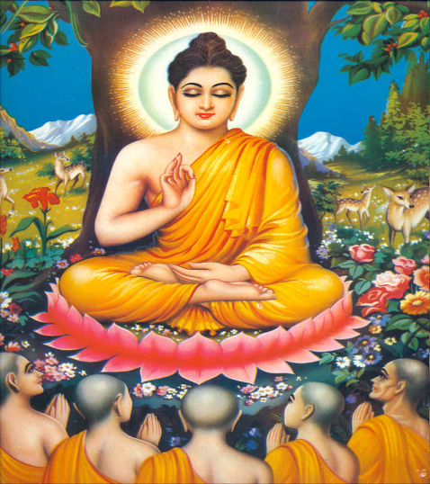 | The Buddha taught the Four Noble Truths in his first sermon at the Deer Park, Isipatana.  Buddha began by explaining that he had found by experience that both a life of hedonistic (pleasure seeking) self-indulgence and extreme self-mortification (denial of pleasure) were harmful and that the way of life that led to his insight, peace and enlightenment was a life of moderation, the Middle Path, which had enabled him to see clearly the Four Truths.

Keywords

Word | Definition
dukkha | The human condition. There is no satisfactory equivalent in English or Welsh, and it is often translated as 'unsatisfactoriness', 'suffering', 'frustration'. It is the first of the Four Noble Truths and one of the three lakshanas.
Samudaya | 'Origin' – the second of the Four Noble Truths, that craving is the origin of dukkha.
tanha | Craving, thirst, attachment.
nirodha | 'Cessation' – the third of the Four Noble Truths, that craving and therefore dukkha can be overcome.
magga | The fourth noble truth - 'The Middle way' – the Noble Eightfold Path.

The first truth “Dukkha” is also the first lakshana, or mark of existence. It is the Buddhist description of the human condition, or to put it another way, it is the diagnosis of the 'illness' from which we all suffer. It is what is wrong. Buddhists see this analysis as neither pessimistic nor optimistic. It is simply realistic. The recognition that all life is dukkha, is the first step in the way to overcoming it
If you have an illness and want to cure it, you need, first of all, to find out what caused it. Then you can attack the cause of the disease and so recover from it. The Buddha said that the same technique can be used to overcome the unsatisfactoriness of life.

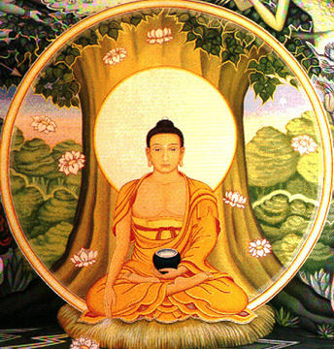

- The Four Noble Truths - Dukkha : All life is dukkha.
The First Truth

'This is the Holy Truth of Suffering: birth is suffering, ageing is suffering, sickness is suffering, death is suffering, sorrow and lamentation, pain, grief and despair are suffering, association with what is loathed is suffering, dissociation from the loved is suffering, not to get what one wants is suffering in short, the five categories affected by clinging are suffering'. (Samyutta Nikaya 5:421-3)

The first truth is the statement that there is something fundamentally wrong with life as most beings experience it. The word translated by 'suffering' is dukkha (P), a word which does mean illness or pain but also a more basic unsatisfactoriness.

There are said to be three forms of dukkha-

- plain ordinary suffering such as the examples listed above, pain and death, frustration of desires, having to watch the suffering of people we love. The more thoughtful and sensitive a person is, the more suffering one is aware of - the sufferings of other people in situations of poverty, famine and war, the sufferings of animals. Even without all the suffering caused by people', evil deeds, nature itself seems built on a system of competition, exploitation and suffering; animals prey on one another, disease and disaster occur through no one's fault.

- Then there is the suffering inherent in all pleasant situations because of the fact that everything changes all the time. The word for impermanence in Buddhism is anicca (P), one of the fundamental characteristics of life. Life does have many beautiful and enjoyable aspects, but these also cause suffering because they do not last and the more beautiful and enjoyable, the more suffering occurs when they pass. All beautiful things decay, our loved ones die, and even if the things and people remain, sometimes it is we who change and suddenly we are bored with something or someone that once gave us great pleasure. This is why even people who outwardly seem to have everything are still unhappy.

The term, sukkha, the opposite of dukkha, denotes happiness, comfort and ease. However, we cannot fulfill ourselves by changing that world, rather we have to look for a cure for this condition within ourselves. The fundamental reason for this is that the world which we experience it is subject to impermanence and subject to change. We constantly seek to create permanence, to hold on to things, but our aspirations slip through our grasp. Change is inevitable and necessary; change is the condition of impermanence; impermanence prevents the possibility of anything abiding. This description is neither happy nor sad, optimistic nor pessimistic; from a Buddhist viewpoint, it is a true analysis, the analysis of the one who has an enlightened view and sees clearly.

- The third form of dukkha is a more subtle dissatisfaction with life itself rather than any specific problem - a sense of frustration at the limitations of human existence, our limited powers, our lack of knowledge, the way we never really know what any of our actions are going to lead to, how we cannot really plan for the future, and that it is all going to end in death anyhow, which makes it seem pointless. A psychological term for this general insecurity is angst or anguish.

The Buddha's insight is only fully understood by looking at the first three Noble Truths together as a complete analysis of the human situation; but it is already clear from analysing the first Noble Truth that what we wish to achieve lies beyond our reach; not that the goal we seek at any moment is inaccessible, but that the achievement of this goal does not confer the happiness we sought through it. Professional ambition, fame, material wealth, financial security, physical and mental health, romance, admiration and friendship are all understandable goals, but the nature of life is such that we are not fulfilled in our achievements. Whatever we gain in any of these spheres is not enough to satisfy us. Dukkha is a deep-seated internal condition brought about through our relationship with a world which cannot satisfy that which we crave. This is the problem we need to overcome: the universal truth that life is unsatisfactory for everyone. Buddhism does not claim to be able to prevent you becoming ill, or getting old, or dying, but it does say that the practice of Buddhism can help prevent you from suffering from dissatisfaction with life.

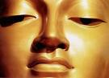
- The Four Noble Truths - Samudaya (the arising of dukkha)

Dukkha is caused by tanha
('thirst', desire, attachment, craving).

'This is the Noble Truth of the Origin of suffering: It is craving which produces renewal of being, is accompanied by relish and greed, seeking its delight now here, now there, in other words craving for sensual experience, craving for being (ie eternal life), craving for non-being (i.e. oblivion).' (Samyutta Nikaya 5)

All conditioned things have a cause, and dukkha is caused by tanha, which literally translates as “thirst”, though it is more usually explained with terms such as 'attachment' or 'craving'. It is easy to acquire a superficial understanding of the relationship between tanha and dukkha, but according to Buddhists, it is the work of possibly many lifetimes to understand it fully.
The reason why we find life to be unsatisfactory is because we rely on things to make us happy, when these things are unreliable. They are unreliable because they are subject to anicca: they change. We want things to stay the same, but they don't: they decay and die. What causes us to suffer is not the things that we rely on for our happiness, or even the experience of pleasure, but the fact that we rely on them. Tanha refers to this relationship of reliance, of attachment. It means desire, wanting, craving. It will cause us dukkha because our actions are dominated by Three Poisons or Three Fires - greed, hatred and stupidity. These poisons are what cause us to grasp at things. Greed refers to our desire to possess things and people in the belief that they will improve our lives. Hatred is a powerful emotion that ties us unhappily to others. Stupidity refers to our ignorance or illusion about the way things really are. When our actions are motivated by the Three Poisons, we end up suffering.

Material desire is only one of the many forms of tanha, and is perhaps one of the most easy to deal with.
- Material desire is a form of tanha. An easy example is that of greed for what money can buy. It is a cliché that money cannot buy happiness, and rich people (especially if they are greedy) can be amongst the most miserable. Buddhists would say it is our greed that creates our dissatisfaction. We want ever more, bigger and better, and suffer because of our lack. We are never satisfied with what we have and constantly crave for more. This state is superbly depicted by the example of the hungry ghost (preta), in the diagram of the Wheel of Life (See Booklet 4). The large belly indicates their overwhelming appetites, their small mouths and necks, their inability to ever satisfy themselves. They are plagued by raging thirst, but can drink only from flaming and infested waters.

Other forms of attachment include attachment to people, or to particular beliefs.

- On the surface it may seem a good thing to be attached to people, but Buddhism says these attachments are unhelpful if they are defined by what you can get out of them. If they are 'giving' relationships, then they are positive. If they are 'taking' relationships, then they are negative and feed dukkha.

- Attachment to particular beliefs is also a dukkha-causing form of tanha. The Buddhist understanding of the Middle Way is not only about avoiding extremes of luxury and asceticism; it is also about avoiding extreme views about the nature of existence, such as nihilism or eternalism, or whether there is a creator, or whether there is life after death. It seems that the Buddha classed these views as metaphysical speculation. They are speculation because we cannot prove them one way or the other, and even if we could, it would not help in the struggle to overcome dukkha.

Buddhists often say that asking such questions is not helpful at all in developing non-attachment. Answers to such questions or views about the nature of the universe can become objects of attachment in themselves, and answers (were it possible to have them!) would not help in the quest for enlightenment.
This idea is illustrated by the parable of the poisoned arrow
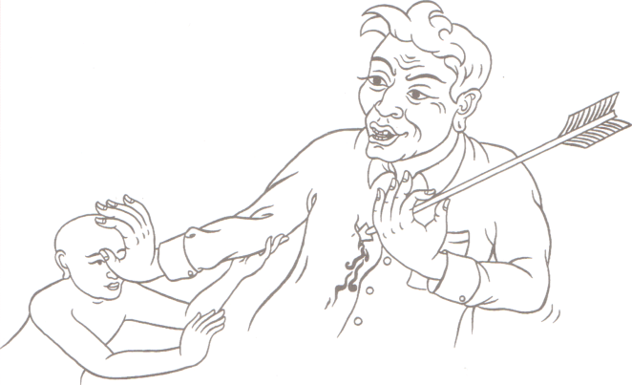

It is as if there was a man struck by an arrow that was smeared thickly with poison; his friends and relatives would summon a doctor. And the man might say 'l will not draw out this arrow as long as I do not know whether the man by whom I was struck was a Brahmin, a Kshatriya, a Vaishya or a Shudra....as long as I don't know his name and his family .... whether he was tall, short or of medium height...' That man would not discover these things, but that man would die.

Majjhima Nikaya i. 429 Adapted from translation in Gethin, Rupert, The Foundations of Buddhism, Oxford, OPUS, 1998

- As well as these attachments, there is also the attachment to one's idea of oneself. This attachment takes many forms. It can involve attachment to the body, or to ideas about one's own prosperity or success.

Some Buddhists consider it helpful to meditate on the transient and unpleasant nature of the body, and many Buddhist temples own skeletons so that people can sit and contemplate them. Buddhists also warn that this type of practice can be unhelpful and even dangerous for someone who is depressed or has an overly negative view of the body anyway. As always in Buddhism, a teaching is only worthwhile if it actually helps to eliminate craving.

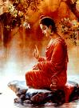
- The Four Noble Truths - Nirodha
(the cessation of dukkha)

'This is the Noble Truth of the cessation of suffering; it is the remainderless fading and ceasing, the giving up, relinquishing, letting go and rejecting of that same craving.' (Samyutta Nikaya 5:421-3)

Tanha can be overcome, therefore dukkha can be overcome.

The third noble truth, known as 'nirodha' or cessation, is that tanha can be overcome, and therefore dukkha can be overcome. Nirodha means “to control”. Control of the craving or thirst of attachment is the third teaching. If we accepted only the first two Noble Truths and eschewed the last two, we would have a teaching about the way things are, but no remedy for this depressing state of affairs. The first two truths diagnose the condition, but the great achievement of the Buddha was to offer a cure; therefore, as far as Buddhists are concerned, he is the physician par excellence. Nirodha is the extinguishing of thirst or craving, to be achieved by rooting out attachment. It results in a state called nirvana (nibbana) in which the fires of craving have ceased to burn and there is no more suffering.

This is sometimes described as 'the good news' of Buddhism, and is a truth that derives from the Buddhist view of interconnectedness, sometimes stated in the formula 'When this arises, that arises. When this ceases, that ceases.' Release from dukkha does not mean that physical pain no longer occurs. It means that the psychological suffering that often comes along with physical pain does not arise (i.e. that it does not lead to further craving). Someone who has perfected non-attachment lives just like anyone else, except that they no longer experience the dukkha associated with craving and ignorance.

Quite clearly, if it is our desire for things that causes us to be frustrated with life, then we must overcome our desires. Then we can overcome our frustration. But a person who feels emotionally empty will want to grasp. Therefore the only way to stop craving is to discover inner satisfaction and an appreciation of life as it really is, to find happiness inside ourselves instead of relying on other things, so there is no need to grasp.
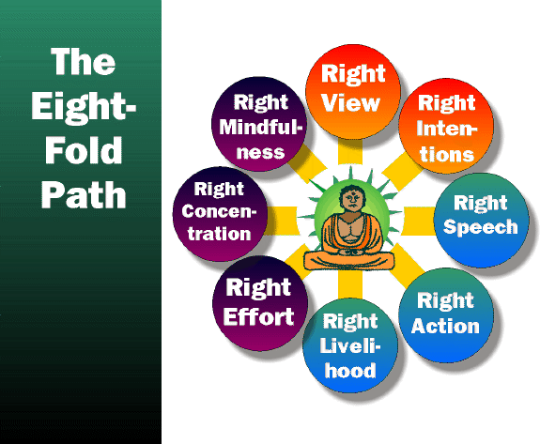

- The Four Noble Truths : Magga (the way)

Tanha can be overcome by following the path.

'This is the Noble Truth of the Way leading to the Cessation of Suffering: It is this Noble Eightfold Path which consists of right view, right intention, right speech, right action, right livelihood, right effort, right mindfulness, and right concentration'.

A life of luxury is one of attachment, when we rely on things outside ourselves to bring us happiness. Yet we have seen that this will actually cause dissatisfaction in the long run. A life of hardship will cause us to crave and want those things that keep us alive. It, too, is a life of suffering. The Buddha said that the way to overcome tanha is to live the Middle Way, between the extremes of luxury and hardship.

This is known as the 'Middle Way', and avoids the two extremes of indulgence in sensual pleasures and self-mortification. It is also known as the 'Noble Eightfold Path', because it outlines eight categories through which purity of mind, calm and insight can be achieved.

