Conscience: Areas of Study:
- What is the conscience? Different views of the conscience (innate, God-given, the “voice of reason” or instilled by others).
- The Bible and conscience
- The nature and role of the conscience: Aquinas.
- The nature and role of the conscience: Butler.
- The nature and role of the conscience: Newman.
- The nature and role of the conscience: Freud.
- The nature and role of the conscience: Fromm.
- The nature and role of the conscience: Piaget.
Evaluate:
Which of the above you would support and why?
Which of the above seem irrational and why?
The nature and role of the conscience: whether conscience is a reliable guide to ethical decision-making.
Does the existence of the conscience and morality act as proof for the existence of God and the afterlife?
If we have a conscience imposed on use by and authority does that mean we are not responsible or autonomous?

The Conscience
A study of conscience crosses over between psychology and philosophy, because it raises questions about the origins and purpose of guilt feelings and feelings of shame in guiding human behaviour.
- Would you ever act against the strong views of your peer group?
- Would you ever disobey the voice of your conscience?
- Can your conscience be mistaken?
All this presupposes that we are clear what conscience is. Is it a "voice" in our heads? Or a feeling in our belly? Is it a process of reasoning as Aquinas suggested, or something purely God-given, as Butler argued? Does our conscience come from an authority figure, as Fromm suggests, or from our upbringing, as Freud argued?
This has important implications for at least two issues. If our conscience is fallible (it can make mistakes) then it is still possible that there is an objective morality – a definite right answer to moral questions. If conscience is infallible, then it is impossible that there can be an objective morality because our consciences disagree so much with each other about issues of right and wrong that we are forced to concede the case for relativism as there cannot be one correct or definitive answer. And if we think God is the originator of conscience, what do we say when God orders us, as apparently he did Joshua, to slay the people of Jericho?
There are also important implications, secondly, for the question of personal freedom and responsibility. If we are in thrall to an authority figure as Fromm argued, then are we really responsible for our actions?

The Bible and Conscience
The Old Testament has no word for ‘conscience’, but it does speak of the true heart helps us understand divine law (church and God’s). Some Old Testament figures experience God calling them to live his will or Law; at other times they experience him probing or judging their hearts (for example the story of Job).
Jesus taught his followers to have a pure heart:
God blesses those whose hearts are pure, for they will see God. Matthew 5:8
What goes into a man's mouth does not make him 'unclean', but what comes out of his mouth, that is what makes him 'unclean' ... the things that come out of the mouth come from the heart, and these make a man 'unclean'. Matthew 15:11,18
This then is how we know that we belong to the truth, and how we set our hearts at rest in his presence whenever our hearts condemn us. For God is greater than our hearts, and he knows everything. Dear friends, if our hearts do not condemn us, we have confidence before God. 1 John 3:19-21
St Paul uses the term συνειδησις - often translated as 'conscience' and 'heart' - to describe the human ability to know and choose the good. He taught that all people, whether or not they are Christians, know what is right and wrong. He said it is written on our hearts:
When outsiders who have never heard of God's law follow it more or less by instinct, they confirm its truth by their obedience. They show that God's law is not something alien, imposed on us from without, but woven into the very fabric of our creation. There is something deep within them that echoes God's yes and no, right and wrong. (Romans 2:14,15, The Message).
For Paul, conscience is the universal knowledge of God's law, an inner guiding of our external behaviour. Paul thinks our conscience can be corrupted and that it can be fallible if we are lead astray from Christ’s guidance.

Aquinas – Rational Conscience
Aquinas held reason in the highest esteem. He said "Reason in man is rather like God in the world." Most famously, Aquinas claimed:
To disparage the dictate of reason is equivalent to condemning the command of God.
Augustine had used the term 'synderesis' to mean an innate knowledge of right and wrong. He held that this was faulty, due to the fall, and that Christians should look to the authority of the Church and Scripture. Aquinas disagreed, holding that conscience has binding force.
Aquinas thought that practical reason, through reflection on human nature, can determine primary moral principles (which he called the 'Primary Precepts'). Our 'conscience' then derives secondary principles ('Secondary Precepts') which are applied. As we practice balancing our needs against the needs of others, we develop Prudence.
Key terms:
synderesis - an innate knowledge of human nature and primary precepts through practical reason
conscientia - deriving secondary precepts, and applying them
prudence - the virtue of right-reasoning in moral matters, balancing ours and others' needs
As with Paul, Aquinas said that a person's conscience could err (go wrong), either 'invincibly', through no fault of their own, or 'vincibly' - through our own fault. For example, if I give money to a man who is begging on the streets, I have good intentions, but my actions are actually unhelpful. If I had considered my actions carefully, I would have seen that I wasn't helping him to improve his situation - if anything, my actions would keep him on the streets longer. I erred 'vincibly', as I would have done differently if I'd thought about it.
Imagine if I'd given the money instead to a homeless charity, who would be able to help this man to find accommodation, help conquering his addictions etc, potentially a much better thing to do. However, I did not know that workers at this charity were abusing the homeless people in their care. Supporting the charity was actually the wrong thing to do, but I couldn't have known this - I erred or got it wrong 'invincibly' - it wasn't my fault.
A different example - the bombing of Dresden. The British government terror bombed Dresden, killing up to 60,000 innocent people. This is a vincible error, as they should have known it was wrong and the consequences were obvious - it was their fault, and they are responsible for what happened.
However, consider a bomb dropped on a weapons factory. Unknown to the British forces, a school was hidden under (or near but on no maps) the factory. It was wrong to bomb the school, but this is invincible error, as it wasn't the fault of the British in this scenario - they couldn't have known about the school.
This example also illustrates what Aquinas thought about Conscience. It isn't a 'feeling' in your heart, like the guilt you feel when confronted with a homeless man. It is the process of reasoning, moving from the Primary Precepts (such as 'It is right to protect and preserve the innocent') to secondary precepts (such as 'It is wrong to give money to people who beg on the streets'). It involves step by step, logical considerations based on the knowledge available.

Joseph Butler (1692-1752) - Intuitive conscience
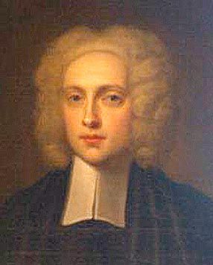
Joseph Butler was an Anglican theologian who identified conscience as the ultimate moral decision-maker.
‘There is a principle of reflection in men by which they distinguish between approval and disapproval of their own actions ... this principle in man ... is conscience' (Butler, Fifteen Sermons, 1726: 21).
Butler argued that humans were influenced by two basic principles, self-love and love of others. In Butler's view, conscience directs us towards acting for the happiness or interests of others instead of focusing on ourselves.
Like Aquinas, Butler argued that conscience determines and judges the rightness and wrongness of actions. He went on to say that conscience operates in situations without any introspection and is the ultimate authority in ethical judgements.
‘Had it strength as it has right; had it power as it had manifest authority, it would absolutely govern the world.' (Butler, Fifteen Sermons, 1726).
Conscience gives instant intuitive judgements about what we should or should not do. It is, ‘our natural guide, the guide assigned us by the Author of our nature'. Conscience is a guide to moral behaviour, innate, placed within us by God, Butler calls it "the law of our nature" and, given its divine origin, must be obeyed: ‘it is our duty to walk in that path, and follow this guide without looking about to see whether we may not possibly forsake them with impunity.' If your conscience instructs you to act in a certain way you have complete authority to do so without considering alternatives. You obey the commands of your consciences without reservation. This is a far more intuitive view of conscience than Aquinas' account, and raises the serious moral question: what happens if our conscience is telling us to do something most people would accept as morally wrong?

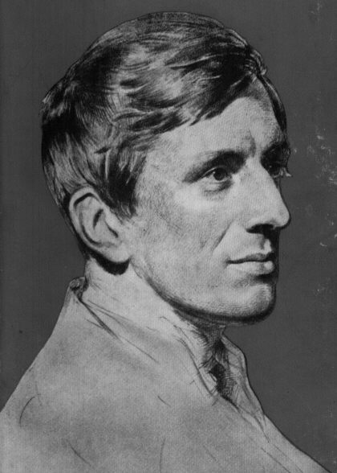
John Henry Newman and conscience (Catholic Influence)
Cardinal John Henry Newman took a more intuitionist approach than Aquinas. He wrote that
"Conscience is a law of the mind ... a messenger of him, who, both in nature and in grace, speaks to us behind a veil, and teaches and rules us by his representatives. John Henry Cardinal Newman, Letter to the Duke of Norfolk).
Newman believed that following conscience was following divine law. Conscience is a messenger from God, and it is God speaking to us. Newman was a devout Catholic, but said in a letter ‘I toast the Pope, but I toast conscience first'. Catholics are obliged to do what they sincerely believe to be right even if they are mistaken. In a commentary to the Vatican documents, a young theologian named Joseph Ratzinger (later to become Pope Benedict) seems to agree.
"Over the Pope as the expression of the binding claim of ecclesiastical authority there still stands one's own conscience, which must be obeyed before all else, if necessary even against the requirement of ecclesiastical authority." (Pope Benedict)
This has led to tensions over ethical debates where individual conscience comes up against moral absolutes, such as the absolute condemnation of abortion and contraception. The Church teaches that using artificial contraception is intrinsically wrong because it breaks the intrinsic link between sex and reproduction. Yet many couples ignore this teaching and maintain the inherent goodness of birth control to limit population growth, or maintain choices over careers.

Freud – psychological account of conscience

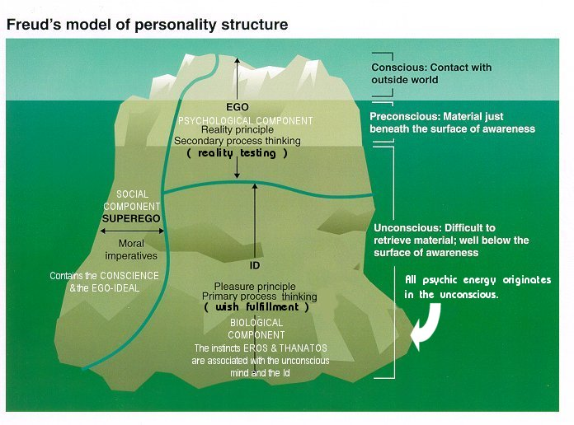

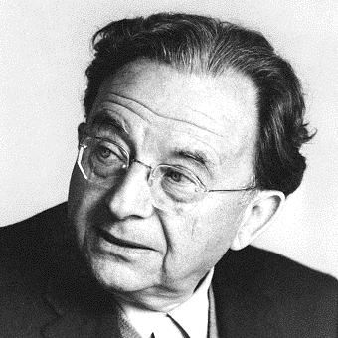
Eric Fromm on conscience
Eric Fromm experienced all the evil of Nazism and wrote his books to reflect on how conscience and freedom can be subverted even in the most civilised societies. In order to explain how, for example, Adolf Eichmann can plead at his trial for mass murder in 1961 that he was only "following orders" in applying the final solution, we can invoke Fromm's idea of the authoritarian conscience.

Authoritarian conscience

The authoritarian conscience is the internalised voice of the external authority, something close to Freud's concept of the superego considered above.
This internal voice may be backed up by fear of punishment, or spurred on by admiration or can even be created because I idolise an authority figure, as Unity Mitford did Adolf Hitler. As Unity found, this blinds us to the faults of the idolised figure, and causes us to become subject to that person's will, so that "the laws and sanctions of the externalised authority become part of oneself" (1947:108).
To Fromm the voice of the authoritarian conscience is obeyed not because it is good but because it is in authority. So, as with the Nazis, ordinary seemingly civilised human beings do atrocious evil because they are subject to a voice which comes essentially from outside them, bypassing their own moral sense.
This authoritarian conscience can come from:
• Projection onto someone of an image of perfection.
• The experience of parental rules or expectations.
• An adopted belief system, such as a religion, with its own authority structure.
"Good conscience is consciousness of pleasing authority, guilty conscience is consciousness of displeasing it" (Eric Fromm 1947:109)
The individual's identity and sense of security thus become wrapped up in the authority figure, and the voice inside is really someone else's voice. This also means obedience becomes the cardinal virtue, and as Eichmann pleaded at his trial, the individual feels he or she has no choice but to obey. The individual gives up the right to criticise, to reflect and to evaluate what the authoritarian conscience dictates.
So in choosing to obey the authoritarian conscience the individual loses their autonomy and creativity, or any action which does not obey the rules of the authority, is seen as rebellion.

Humanistic conscience

The humanistic conscience, in contrast, is "our own voice, present in every human being, and independent of external sanctions and rewards" (1947:118). Fromm sees this voice as our true selves, found by listening to ourselves and heeding our deepest needs, desires and goals. It can be hard to access this humanistic conscience.

Piaget
Many psychologists have come to question Freud's understanding of the conscience, and see a well-developed conscience as part of a healthy human mind. However, most continue to reject the notion of a God-given conscience. Piaget was a developmental psychologist. He believed that by studying human behaviour, you could see how conscience develops over time. It certainly isn't something that humans are born with. He highlighted four developmental stages:
- 0-2 years. During this stage, babies would learn about the world around them through their senses and by moving about. They become able to differentiate themselves from the world around them, and learn about the permanence of objects.
- 2-7 years. During this stage, children develop language, although they find it hard to see the world from a viewpoint other than their own. They classify things by single shared features.
- 8-11 years. They are able to think logically to develop explanations about the world around them.
- 11-15 year. They can reason using abstract concepts. They begin to think about the future, the hypothetical and ideological issues.
According to this model, a person doesn't have a fully functioning conscience before the age of 11.

Evaluate - How much notice should people take of their conscience when making moral decisions?

People should take notice of their conscience because…
The law and religion is not always right and does not always reflect changing society. For example many young Catholics use contraception when the Church does not allow it. They have made this decision because their conscience tells them that protecting themselves from unprepared pregnancy and sexually transmitted diseases is the right thing to do.

Martin Luther King followed his conscience and went
against the laws to fight for civil rights. The outcome of this was a new set of laws which were fairer than the previous racist laws that had been in place.
The conscience can give you an alternative to established norms and rules

Religious people view the conscience as the voice of God therefore it should be followed as it will always lead to the good.

People are conscientious objectors to war, meat eating, testing on animals etc. this shows that the conscience can lead to positive social changes.

People should not rely on their consciences because…
Even Aquinas said that the principles that guide a conscience might be misleading if the person did not have the correct faculty of reason, so the conscience cannot always be relied upon to make the correct decisions. A Catholic Christian might argue that the Bible is as important if not more important than the conscience when making moral decisions.

If you give conscience supreme authority then what about all those people who would say that their conscience told them to kill or do other harmful acts.

If the conscience really is the voice of God then why do so many people feel torn when making moral decisions, one would expect the voice of God to be clear.

The conscience should not really be relied upon, as its existence is not proven. The conscience could just be norms and values of a particular society and not an inner voice. Or as Freud argued, conscience is associated with guilt

It would seem that conscience is irrational and that there are better ways of making moral decisions such as the principle of utilitarianism, doing the greatest good for the greatest number

However, instead of viewing the conscience as the voice of God, one could argue that our conscience is a stream of thought that allows us to reflect before making decisions. In this light then the conscience can only be a positive tool in moral decision making.
Emphasis on the conscience could allow for a more relative approach to ethics, as one cannot predict how our conscience will direct us.

