Key Bodhisattvas: Avalokiteśvara
- Translates as Lord who contemplates
- Embodies the compassion of all Buddhas
- Early etymology suggests meaning as looks down upon sound, i.e. hears the cries of sentient beings who need help
- Possibly the most popular of all figures in Buddhist legend. Avalokiteshvara is beloved throughout the Buddhist world—not only in Mahayana Buddhism but also in Theravada
- This popular bodhisattva is sometimes depicted with normal male or female human features.
- However, Avalokitesvara is also frequently depicted with ultra human characteristics such as a 1000 arms and 11 heads.
- It is important to make note of the fact that the ultra human representations of Avalokitesvara are not meant to be frightening. Instead, the bodhisattva of compassion was given these ultra human features in order to work harder to free all sentient life from suffering.
- In Chinese Buddhism, Avalokiteśvara has become the somewhat different female figure Guanyin.
- Guanyin statues commonly depict her holding a vase which she is tipping over. The vase is filled with special water – the ‘dew of compassion’- that she is liberally dispensing. Additionally, the water has healing properties that will prolong life and relieve suffering.
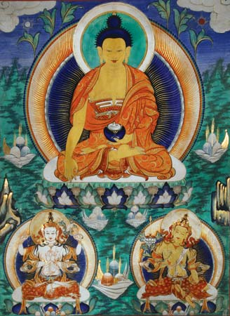
SOURCES
- The Lotus Sutra is generally accepted to be the earliest literature teaching about the doctrines of Avalokiteśvara. These are found in the Lotus Sutra chapter 25.
- This chapter is devoted to Avalokiteśvara, describing him as a compassionate bodhisattva who hears the cries of sentient beings, and who works tirelessly to help those who call upon his name.
- A total of 33 different manifestations of Avalokiteśvara are described, including female manifestations, all to suit the minds of various beings.
- The chapter consists of both a prose and a verse section. This earliest source often circulates separately as its own sutra, called the Avalokiteśvara Sūtra, and is commonly recited or chanted at Buddhist temples in East Asia.
- According to the Kāraṇḍavyūha Sūtra, the sun and moon are said to be born from Avalokiteśvara's eyes, Shiva from his brow, Brahma from his shoulders, Narayana from his heart, Sarasvati from his teeth, the winds from his mouth, the earth from his feet and the sky from his stomach.
ICONOGRAPHY
Avalokiteśvara has an extraordinarily large number of manifestations in different forms (including wisdom goddesses (vidyaas) directly associated with him in images and texts). Therefore, the iconography is rich and varied.
Key Bodhisattvas: Mañjuśrī
- Translates as gentle glory in Sanskrit
- Personifies supreme wisdom
- He is also known as Mãnjughoṣa (“Sweet Voice”) and Vāgīśvara (“Lord of Speech”).
- Associated with prajna (insight) in Mahayana Buddhism
- One scholar has claimed that Mañjuśrī is the oldest and most significant bodhisattva in Mahāyāna literature
- Manjushri is also considered to be a high level bodhisattva similar to Avalokitesvara. This high rank is because he has already attained Buddhahood but has not fulfilled his vows. As a result, he remains a bodhisattva by choice. However, in Tibetan Buddhism he is considered to be a fully enlightened Buddha and also a “yidam” or meditational deity.
- His cult spread widely in China in the 8th century, and Mount Wu-t’ai in Shansi province, which is dedicated to him, is covered with his temples.
- Though he is usually considered a celestial bodhisattva, some traditions endow him with a human history.
- He is said to manifest himself in many ways—in dreams; as a pilgrim on his sacred mountain; as an incarnation of the monk Vairocana, who introduced Buddhism into Khotan; as the Tibetan reformer Atīśa; and as the emperor of China.
- This important bodhisattva is also known by the longer name “Manjusrikumarabhuta”. This longer name means “Manjushri the youth” or “Prince Manjushri”. Therefore, depictions of him tend to be youthful and he can be misperceived as a teenager. Although the truth is that he is one of the oldest bodhisattvas.

ICONOGRAPHY
Mañjuśrī is depicted as a male bodhisattva wielding a flaming sword in his right hand, representing the realisation of transcendent wisdom which cuts down ignorance and duality.
Mañjuśrī is often depicted as riding on a blue lion, or sitting on the skin of a lion. This represents the use of wisdom to tame the mind, which is compared to riding or subduing a ferocious lion. To emphasize wisdom, the lotus flower grows over his left shoulder with the Prajnaparamita Sutra resting on the blossom.

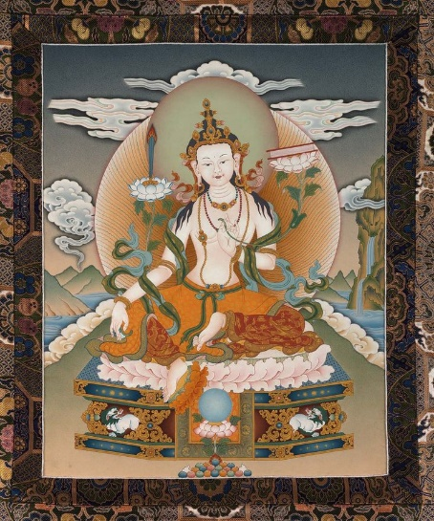
SOURCES
- Mañjuśrī is first referred to in early Mahayana sutras such as the Prajnaparamita sutras and through this association very early in the tradition he came to symbolize the embodiment of prajñā (transcendent wisdom).
- The Lotus Sutra assigns him a pure land called Vimala, which according to the Avatamsaka Sutra is located in the East. His pure land is predicted to be one of the two best pure lands in all of existence in all the past, present and future. When he attains buddhahood his name will be Universal Sight.
- In the Lotus Sūtra, Mañjuśrī also leads the Nagaraja's daughter to enlightenment. He also figures in the Vimalakirti Sutra in a debate with Vimalakirti where he is presented as an Arhat who represents the wisdom of the Hinayana.
Key Bodhisattvas: Maitreya
- The name Maitreya is derived from the Sanskrit word maitrī "loving-kindness", which is in turn derived from the noun mitra "friend".
- Maitreya, in Buddhist tradition, the future Buddha, presently a bodhisattva residing in the Tushita heaven, who will descend to earth to preach anew the dharma (“law”) when the teachings of Gautama Buddha have completely decayed.
- Maitreya is the earliest bodhisattva around whom a cult developed and is mentioned in scriptures from the 3rd century ce.
- He was accepted by all schools of Buddhism and is still the only bodhisattva generally honoured by the Theravada tradition.
- In the Lotus Sutra he is also referred to as Ajita
- The prophecy of the arrival of Maitreya refers to a time in the future when the dharma will have been forgotten by most on the terrestrial world.
- The religious belief of Maitreya apparently developed around the same time as that of Amitābha, as early as the 3rd century CE
- In Mahayana Buddhism, buddhas preside over pure lands, such as Amitābha over Sukhavati. Once Maitreya becomes a buddha, he will rule over the Ketumati pure land, an earthly paradise sometimes associated with the city of Varanasi (also known as Benares) in Uttar Pradesh, India.
- His worship was especially popular from the 4th to the 7th century, and his images are found throughout the Buddhist world; many of them beautifully convey his characteristic air of expectancy and promise.

ICONOGRAPHY
Maitreya is typically pictured seated, with either both feet on the ground or crossed at the ankles, on a throne, waiting for his time. He is dressed in the clothes of either a bhikkhu or Indian royalty.
Usually he wears a small stupa in his headdress that represents the stupa with relics of Gautama Buddha to help him identify it when his turn comes to lay claim to his succession.
He can also be holding a dharmachakra (the eight-spoked wheel) resting on a lotus.
A khata(traditional ceremonial scarf) is always tied around his waist as a girdle.

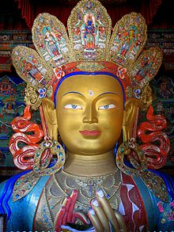
SOURCES
One mention of the prophecy of Maitreya is in the Maitreyavyākaraṇa. It implies that he is a teacher of meditative trance sādhanā and states that gods, men and other beings:
“Will lose their doubts, and the torrents of their cravings will be cut off: free from all misery they will manage to cross the ocean of becoming; and, as a result of Maitreya's teachings, they will lead a holy life. No longer will they regard anything as their own, they will have no possession, no gold or silver, no home, no relatives! But they will lead the holy life of oneness under Maitreya's guidance. They will have torn the net of the passions, they will manage to enter into trances, and theirs will be an abundance of joy and happiness, for they will lead a holy life under Maitreya's guidance.”

Evaluate the view that the Bodhisattva ideal is unhelpful to Buddhists aiming for nirvana (40 marks)
Some Possible Judgements (thesis)
My thesis was/is…

The Bodhisattva ideal and the arahant path are equally valid ways of attaining enlightenment and, ultimately, (pari)nirvana.
The Bodhisattva ideal is helpful for another person seeking parinirvana. That is because it is with the help and guidance/intervention of Bodhisattvas that one is most likely to gain liberation from suffering. A bod. also has attained nirvana-with-remainder themselves. (Mahayana view).
The ideal is helpful because visualising, chanting the names of or seeking the help of some of the key Bodhisattvas, such as Avalokiteśvara or Amitabha, can result in help or a better rebirth.
The Bodhisattva ideal is unhelpful for a person seeking parinirvana because, once a person takes the Bodhisattva vow, they are committed to staying within the cycle of samsara in order to aid other beings.
Evaluate the view that the Bodhisattva ideal is unhelpful to Buddhists aiming for nirvana (40 marks)
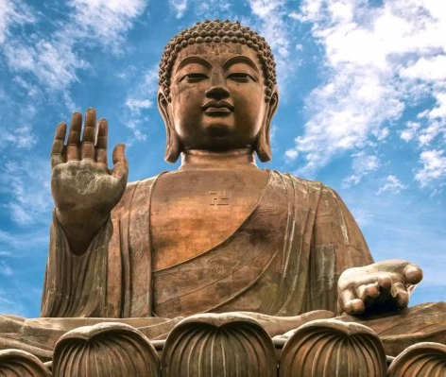
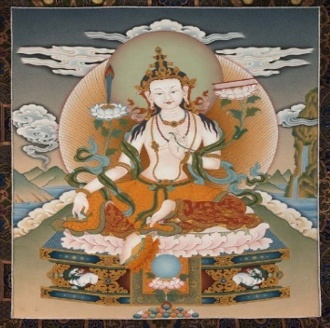
Key concepts/Knowledge & Understanding
Maitreya
Loving-kindness; restores the Dharma in the future
Mañjuśrī
Supreme wisdom; can turn up in dreams!
Amitabha
Infinite light; dwells in Sukhavati (Pure Land)
Avalokiteśvara
Compassion; hears the cries of sentient beings
Key Bodhisattvas
Can intercede in people’s lives as a result of meditation, chanting or visualisation.
May be archetypes rather than real beings (Jung).
Arhat (also Arahant)
- ‘Perfected person’/’worthy one’
- 4 stages of awakening
- Solitary path
- 5 monks heard the Deer Park Sermon, were enlightened and became arhats
- Ther: arhat is pursued as it leads to parinirvana; very demanding – follow 8fold path; monks and nuns only; supported by Pali Canon
- Maha: arhat is a less advanced level on way to enlightenment

Bodhisattva
- An enlightened being who delays parinirvana in order to help other sentient beings
- Maha: Bodhisattva ideal embodies the compassion of the Buddha; n-with-rem only; ultimate goal; supported by Lotus sutra; 6 paramitas (attributes)
- Ther: Buddha was a Bodhisattva (Jataka Tales); other Bodhisattvas (e.g. Avalokiteśvara) are revered but ordinary person cannot become one.

Nirvana
Liberation from suffering

Evaluate the view that the Bodhisattva ideal is unhelpful to Buddhists aiming for nirvana (40 marks)
Some Discussion Possibilities/Styles
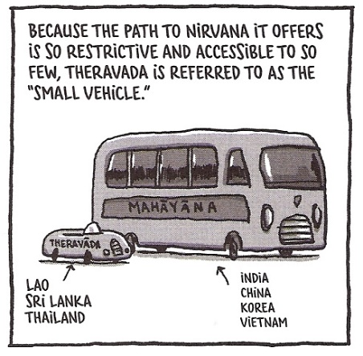
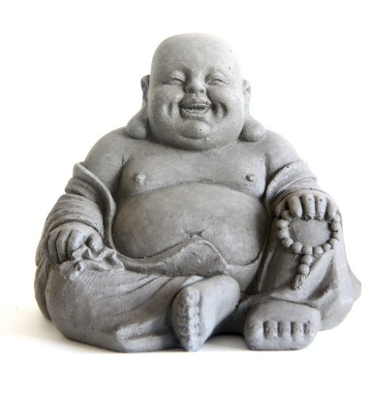
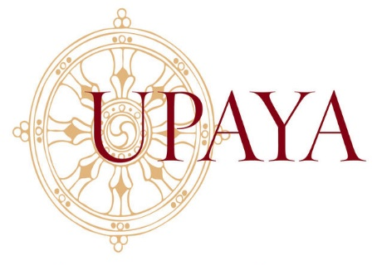
SO
HOWEVER
Theravada scholars often question the authenticity of the ‘scripture’ that directs Buddhists to follow the path of a Bodhisattva – i.e. the famous Lotus Sutra. They claim that if this was what the Buddha wanted he would have instructed his followers to do so during his lifetime, and it would thus be recorded in the Pali Canon. If the Lotus Sutra is inauthentic, then the Bodhisattva path may be inaccurate and actually delay people on their way to nirvana.
Upaya kaushalya is a term used in Mahayana, meaning “skilful means”, whereby the Buddha gives people the teaching they are ready for, whatever they need at this particular stage of development. His previous teachings were suitable for that time but the bodhisattva teaching is for this time. 5000 people left when they heard this sermon: people not ready to hear.
BUT
However, an arhat’s enlightenment will lead to parinirvana, whereas It could take aeons for a Bodhisattva after taking the Bod. vow. The arhat route is swifter, direct and therefore more useful.
In the Lotus Sutra a key theme is the buddhanature (buddha dhatu), so one can be reassured enlightenment is possible for them.
HOWEVER
In Maha the Bodhisattva path is available to all, since the Lotus Sutra states Buddhahood is in everyone, whereas the arhat in Ther is only for monks and nuns, and is therefore inferior.
Such devotions also run the risk of treating Bodhisattvas like deities. This makes Buddhism seem superstitious and lessens its credibility, making it unhelpful e.g. for Western/new Buddhists. The ‘laughing Buddha’ (an incarnation of Maitreya), in fact, is often misunderstood by non-Buddhists as Gautama Buddha and is not taken seriously.
AND
The Buddha’s teaching of ehipassiko suggests an independent approach to the dharma is best!
BUT
Upaya could also mean both arhat or bodhisattva are useful, that both are equally valid.
If this is true then the B. ideal may seem even more helpful because it is a later teaching.
BUT
Visualising, chanting the name of or making devotions (e.g. flowers) and seeking the help of key Bodhisattvas such as Avalokiteśvara can aid someone on their journey towards liberation. .from suffering.
NONETHELESS
Even though this is a common criticism, it is believed by Ther that Kisa Gotami became an arhat and she was merely an ordinary woman to begin with, who committed to the dharma, and thus gained enlightenment. .IGHTlightenment.
Evaluate the view that the Bodhisattva ideal is unhelpful to Buddhists aiming for nirvana (40 marks)
Scholarship/sources of wisdom and authority
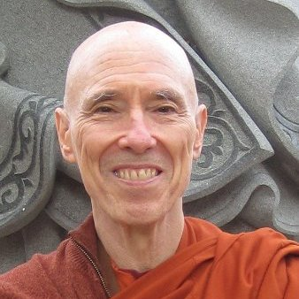
Ven. Bikkhu Bodhi (Ther)

“I can announce to them [those listening] that they shall become Buddhas, for the benefit and out of compassion for the world. The way in which you walk is the Bodhisattva way. By gradually practicing and learning all of you will become Buddhas.”

Lotus Sutra
“…the Theravāda tradition has absorbed the bodhisattva ideal into its framework and thus recognizes the validity of both arahantship and Buddhahood as objects of aspiration.”

A key sutra in Mahayana, believed to be a sermon given by the Buddha towards the end of his life.

“[The Buddha’s] uncanny ability to reach deep into the hearts of those who came to him for guidance and teach them in the unique way suitable for their characters and situations…This ability betokens a depth of compassion, a spirit of selfless service, that harmonizes better with the later concept of the bodhisattva than with the canonical concept of the arahant.”

The Bodhisattva Vow
“The number of living beings is endless: I vow to save them all.
The amount of suffering in the world is infinite: I vow to end it all.
The number of dharmas in the world is beyond measure: I vow to learn them all.
The Buddha-Way is unsurpassable: I vow to accomplish it.”
Once a person takes this vow, they are on the Bodhi-sattva path.

“I have no teacher and one like me exists nowhere in the world…I am the Teacher Supreme. I alone am a Fully Enlightened One whose fires are quenched and extinguished.”
The Buddha in the Majjhima Nikaya

