**Design Arguments**

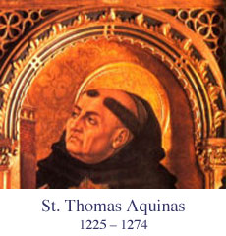St. Thomas Aquinas was an important theologian and philosopher whose work on the nature and existence of God and his arguments for a moral code based on the ‘natural law’ God has instilled in the universe have formed the central teachings of the Roman Catholic Church. He sought to bring faith and reason together in order to develop the place of theology in the world.

The argument from design finds its origins in **Aquinas’** *Summa Theologica* and is the fifth of his *five ways* of proving the existence of God. Aquinas’ argument can be explained as follows:

“The fifth way is taken from the governance of the world. We see that things which lack knowledge, such as natural bodies, act for an end, and this is evident from their acting always, or nearly always, in the same way, so as to obtain the best result.

Hence it is plain that they achieve their end, not fortuitously, but designedly. Now whatever lacks knowledge cannot move towards an end, unless it be directed by some being endowed with knowledge and intelligence; as the arrow is directed by the archer.

Therefore some intelligent being exists by whom all natural things are directed to their end; and this being we call God.”

Aquinas argued from **design qua regularity**. He saw the overall order in the world as proof of a designer: ‘**this being we call God.’**

G1111161

Aquinas stated that everything works together to achieve order, despite the fact that inanimate objects have no mind or rational powers to achieve this.

Speak for yourselves!

G0192980

Aquinas explained his point by using the example of an arrow, saying that for an arrow to reach its destination it must be directed first of all by the archer. In the same way, ‘natural bodies’ seem to act in a regular fashion to reach a specific purpose. As they, like the arrow, are not able to direct themselves, there must be a God doing the directing.

**Aquinas’ argument is mainly an argument from design. As you can see, he refers to the existence of design without really proving that design exists. He is mainly interested in proving that God put the design there. We can perhaps assume that Aquinas thought the evidence *for* design was too overwhelming to have to demonstrate.**

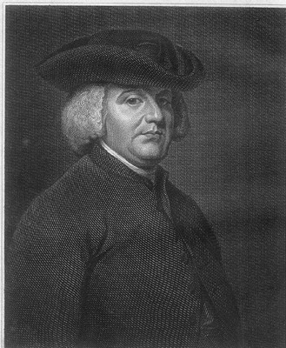**William** **Paley** (1743-1805) then took this further when he formed his own version of the teleological argument in his book *Natural Theology (1802)*. **Paley presents both an argument *for* and an argument *from* design.**

Paley uses the analogy of the watchmaker to explain his argument. He asks you to imagine a man walking across a heath. The man comes across a stone and a pocket watch and analyses both. His inspection of the stone leads him to conclude that it could have been there forever; there is nothing about the stone that leads the man to believe it lies on the heath for a particular reason.

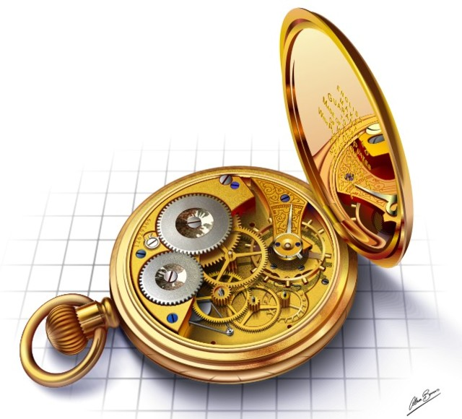

However, imagine he were to inspect the pocket watch in the same way. Paley concludes that the man would not be able to make the same claim about this complicated, intricate, purposeful piece of machinery that he made about the stone.

To the contrary: all evidence would show that the watch had been designed for a purpose (to tell the time) and designed with the necessary regularity (the mechanisms inside) to meet its purpose.

Paley claimed that, in the same way, intricacies existed within nature that could not have come about by chance. Many of these are mentioned in your blue textbook (p. 76). These are just a couple of his examples:

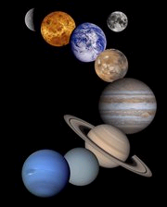

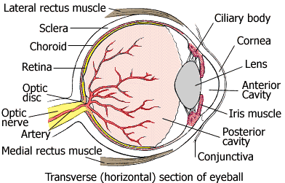

**Paley compares the eye to a designed instrument such as the telescope, and concludes that ‘*there is precisely the same proof that the eye was made for vision, as there is that the telescope was made for assisting it.’***

(Dawkins, The Blind Watchmaker (1986, p.5).

Paley was also fascinated by the rotation of the planets in our solar system and felt strongly that the existence of gravity and the laws of motion were even more evidence of a divine hand at work in the design of the universe.



In the 20th century, **Arthur Brown** argued that the ozone layer was also evidence of design. The ozone layer absorbs harmful radiation that would otherwise harm or kill living things on Earth. *‘the ozone layer is mighty proof of the creator’s forethought. Could anyone possibly attribute this device to a chance evolutionary process? A wall which prevents death to every living thing, just the right thickness and exactly the correct defence gives every evidence of a plan’*

## The Anthropic principle

In his book *Philosophical Theology (1930)*, Frederick R. Tennant elaborated on the teleological arguments that had been put forward in the past, with his **anthropic principle** (revolving around humankind). He believed that the best evidence of design could be seen in the way the universe supports intelligent life.

He developed the anthropic principle to include the **aesthetic principle*.***Here, Tennant argued that nothing seen in Darwin’s theory of evolution can explain why humans feel a love and appreciation of art, music, literature and other beautiful things. He argued that, since these characteristics do not aid us in survival in any way, natural selection cannot account for their existence. So, why do we hold this ability to appreciate beauty? Tennant believed that this capacity for joy was put in us by our designer = **God**.

**Another contributor to the anthropic principle:**



**Richard Swinburne** states that the complexity of the universe makes it difficult to believe that there is not a designer at work. He has accepted the *Anthropic Principle*, noting that even though the world could just as easily have become chaotic following the Big Bang, the fact that it has not points to an external designing or ordering force.

Swinburne uses a *fine tuning* argument, which states that the earth is too finely tuned to be like this on its own. Science can explain the fine tuning- that scientific laws work well together, that certain genetic mutations have worked in humankind’s favour etc etc. What science *cannot* explain is **why** all these occurrences should have coordinated themselves over long periods of time to work in our favour.

They call my work a “modern design argument”…probably because I’m still alive so it’s modern, innit

#### Swinburne says that science can only use scientific/natural laws to explain phenomena. This scientific explanation cannot extend to explaining the laws themselves, instead it is understood that they are ‘brute fact’, in other words, they just *are*.

#### Swinburne proposes a *personal* explanation of the scientific laws. That is, we should understand the existence of scientific laws in terms of a purpose which has been put in place for them. This purpose can be best explained by the existence of an omnipotent being.

#### Ockham’s razor famously states that *all things being equal, the simplest answer is probably the best answer*. Swinburne argues that the existence of a designer-creator being is the best, simplest answer to the temporal order (regularities of succession) which exist throughout space, throughout all time.

#### He argues that it is far simpler than to explain scientific laws as brute fact or random chance.

**Inference to the best explanation**

Swinburne argues that, given all the evidence available to us, we can infer (using inductive reasoning) that the best explanation is **the existence of God.**

#### **Challenges to Design Arguments**

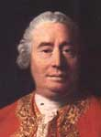

###### The Scottish philosopher David Hume produced a detailed teleological argument in his book *Dialogues concerning natural religion* (1779). Note that this was written before Paley’s own version of the argument from design.

###### However, he did this in the fictional voice of Cleanthes, shortly before Philo (another fictional character who echoes the views of Hume himself) outlines for Cleanthes what the flaws are of using the design argument as an argument for the existence of God (especially the God of classical theism).

**1. What Cleanthes says**

* Every aspect of the natural world bears the marks of apparent design and fits together like a machine.
* For example, the human eye is brilliantly suited to seeing: the lens, cornea and retina seem to have been thought up by a superior intelligence. The design and construction of the eye is more skilful than anything that could have been done with human hands.
* This creator or designer must have had an intelligence in proportion to the magnitude and grandeur of his work and so must have been the God of classical theism (omnipotent, omnipresent, omniscient, benevolent).
* Analogy to building a house

**2. Philo’s criticisms of Cleanthes’ arguments**

* To use an analogy properly the two things being compared must be similar. If you were to look at a house you may well conclude that a builder or architect designed it for a purpose and that the house would show much evidence of this design.

However, when we are comparing an entire universe to something like a house, and expecting to be able to draw the same conclusions i.e. that the universe has a designer, the analogy can not be successful as there is no real point of comparison. We cannot compare our experience of a house with our experience of the universe, as we do not know enough about the universe to make judgments about it.

* By analogy, when we compare God to a human designer we limit God to a less than perfect being (like humans are).
* If we were to take such an analogy and examine it in more depth we might come to the conclusion that as many human constructions or items of machinery are built and designed by *many* people, we would have to seriously consider the suggestion that the universe was made by *many* Gods.

**3. Philo’s alternative explanations for the apparent order and design in the world**

* At one point, Philo gets very close to suggesting a pre-Darwinian theory along the lines of natural selection. He argues that animals, which are not well adapted to their surroundings, will simply die and therefore the apparent ‘design’ in the animal kingdom exists due to the sheer need for survival.

Since Darwin published his findings on evolution nearly 100 years later, the theory has been accepted as the most credible way to account for apparent design displayed by animals and plants.

G0113677

* Another alternative that Philo toys with is that the universe is actually being spun from the abdomen of a gigantic spider. His point is that apparent order and design do not necessarily point to an intelligent brain. Webs are spun with order and design but they are not created with brain power, they are created with abdomen power!

This might sound absurd but Philo maintains that in a world dominated by spiders, it would be just as likely that they would think of their God as spinning webs as we would of God having human-like thought.

**Hume’s other views on the design argument:**

* The existence of evil seriously undermines the likelihood of a loving God. Therefore the design argument does not necessarily point to the God of classical theism.
* Even if the design argument is valid, the design could have been by lesser gods or an apprentice God. This world might be the last of many failed experiments in ‘design’ by such an apprentice God.
* Hume also had sympathies with the **Epicurean Hypothesis,** which states that initially the universe was chaotic but the huge amount of time that the universe has existed has resulted in natural forces eventually calming down and ordering themselves into some kind of system. This has then mistakenly given us the illusion of design.

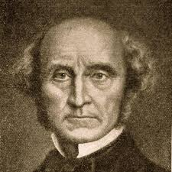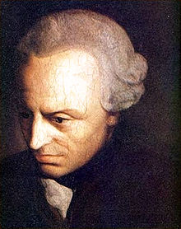

**John Stuart Mill,** known for his utilitarian ideas, argued that evil alone is enough to prove that *either* God does not exist *or* that if he does, he is not all-loving. The pain and suffering that humanity is put through on a daily basis must force us to question the existence of the God of classical theism. Mill argues that nature is far crueller than the human mind. By implication, the “evidence” of design in nature points to a cruel designer, or else no designer at all. We will see more about this when we discuss the evidential problem of evil.

*Mill writes, “if the law of all creation were justice and the creator omnipotent then, in whatever amount suffering and happiness might be dispensed to the world, each person’s share of them would be exactly proportioned to that person’s good or evil deeds….every human life would be the playing out of a drama constructed like a perfect moral tale…[yet] no one is able to blind himself to the fact that the world we live in is totally different from this…the order of things in this life is often an example of injustice, not justice”.*

**J.S. Mill, Nature and Utility of Religion (1874)**

###### Immanuel Kant questions how we can even be sure that order exists in the world. He rejects design arguments, saying that humans naturally categorise and order our own experiences. We could therefore be projecting order onto the world when, in truth, it is not there. The world might well be in chaos and we would not necessarily know, due to the fact that we cannot see noumena, only phenomena. Kant argued that the existence of God can only be proven using the existence of our inner moral ‘law’ as the starting point.

**Specific Challenges to Arguments *for* Design**

**Darwinism and Dawkins**

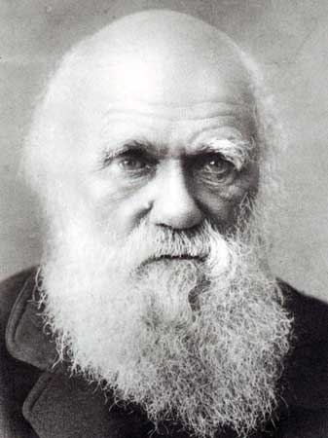

A task for you!!!

Using the information in the library or any other resources you have access to, answer the following questions:

1. What was the name of Darwin’s book, which explained the theory of evolution, and what year was it published?

2. Explain the process of **evolution** in 150 words or less, including **natural** **selection**

3. How does the theory of evolution challenge the design argument?

4. How can the *Anthropic Principle* take on this challenge?

5. Is Darwinism the *strongest* challengetothe design argument in your view? Explain your answer.

##### **Dawkins’ “special”[Picture of Richard Dawkins with binoculars] page**

“I do not want the reader to underestimate the prodigious works of nature, and the problems we face in explaining them.”

Richard Dawkins, *The Blind Watchmaker* (1986) p.37

“The living results of natural selection... impress us with the illusion of design”.

Richard Dawkins, *The Blind Watchmaker* (1986) p.21

“Many theologians who call themselves evolutionists…smuggle God in by the back door: they allow him some sort of supervisory role over the course evolution has taken.”

Richard Dawkins, *The Blind Watchmaker* (1986) p.316

Please leave me alone.

I’d like to finish my bird watching

“The only watchmaker in nature is the blind forces of physics, albeit deployed in a very special way. A true watchmaker has foresight: he designs his cogs and springs, and plans their interconnections, with a future purpose in his mind’s eye.

Natural selection, the blind, unconscious, automatic process which Darwin discovered, and which we now know is the explanation for the existence and apparently purposeful form of life, has no purpose in mind. It has no mind and no mind’s eye. It does not plan for the future. It has no vision, no foresight, no sight at all. If it can be said to play the role of watchmaker in nature, it is the *blind* watchmaker.”

Richard Dawkins, *The Blind Watchmaker* (1986) p.5

Richard Dawkins argues that the impressive system of natural selection creates an ‘illusion’ of design which theists have misinterpreted as actual evidence of design.

In response, specifically, to the anthropic and aesthetic principles, Dawkins explains that genes alone are responsible for what we now know as intelligent life. He also uses the word **‘memes’** to describe units of ‘cultural inheritance’. Memes are essentially ideas and have also been operated on by natural selection: we inherit some cultural values of those who came before us, who were strong enough to pass on their genes. For this reason, Dawkins argues, humans appear to have an appreciation of beauty but it is actually no more than part of the survival mechanism.