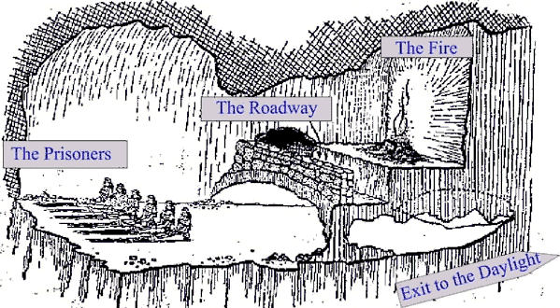

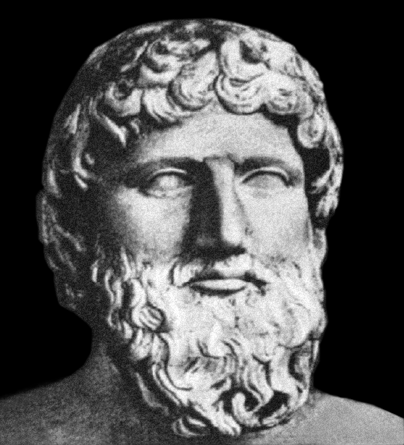

**THE PRISONERS**

You are a prisoner in a cave into which no sunlight ever penetrates. You cannot remember a time when you were not a prisoner, shackled and immobile. In fact you don't even know you are a prisoner. As far as you are concerned, your situation is completely normal. You know there are other prisoners. You' ve never seen them, because of the dark - but you talk to them. Shapes appear and disappear in front of you. You give them names, like "tree", "girl", "house" and you discuss them excitedly with your fellow prisoners. You are satisfied with your life, because the cave is your life. You cannot imagine anything different.

**THE FIRE**

Although the prisoners don't know it is there, the fire is the source of all their "knowledge" about their world of the cave. Without its light projecting images of the objects carried along the causeway, their lives would be lived in total darkness. There would be nothing to look at and nothing to talk about.

**THE ROADWAY**

Unknown to the prisoners, this elevated causeway crosses through the cave. No one knows where it leads to. Unseen by the prisoners, life-sized two-dimensional cut -outs of various objects, like "trees", "girls" and "houses", are constantly being carried across this causeway. Because of the fire, shadows of them are projected on to the far wall of the cave. These shadows are what the wretched prisoners take to be real objects. They give names to them, and talk about them, because they know no better. In fact their "reality" is nothing but the shadow of a two-dimensional copy.

**EXIT TO THE DAYLIGHT**

Suppose one of the prisoners (we could call him "Socrates") escaped, and made his way up the rough track and into the daylight. On the way up, he'd seen the fire, and the causeway, and the two-dimensional figures. In the real world above, to begin with, he was blinded by the sunlight. As he got used to it, he was amazed by the shapes, the colours, the textures - now he knew what a tree was, or a girl, or a house. He couldn't wait to get back down into the cave to tell the others. He tried to describe the brilliance of the light and beauty of the things he'd seen. The prisoners soon got tired of his nonsense and killed him. They preferred the pictures on the wall. They preferred the world they knew and understood.